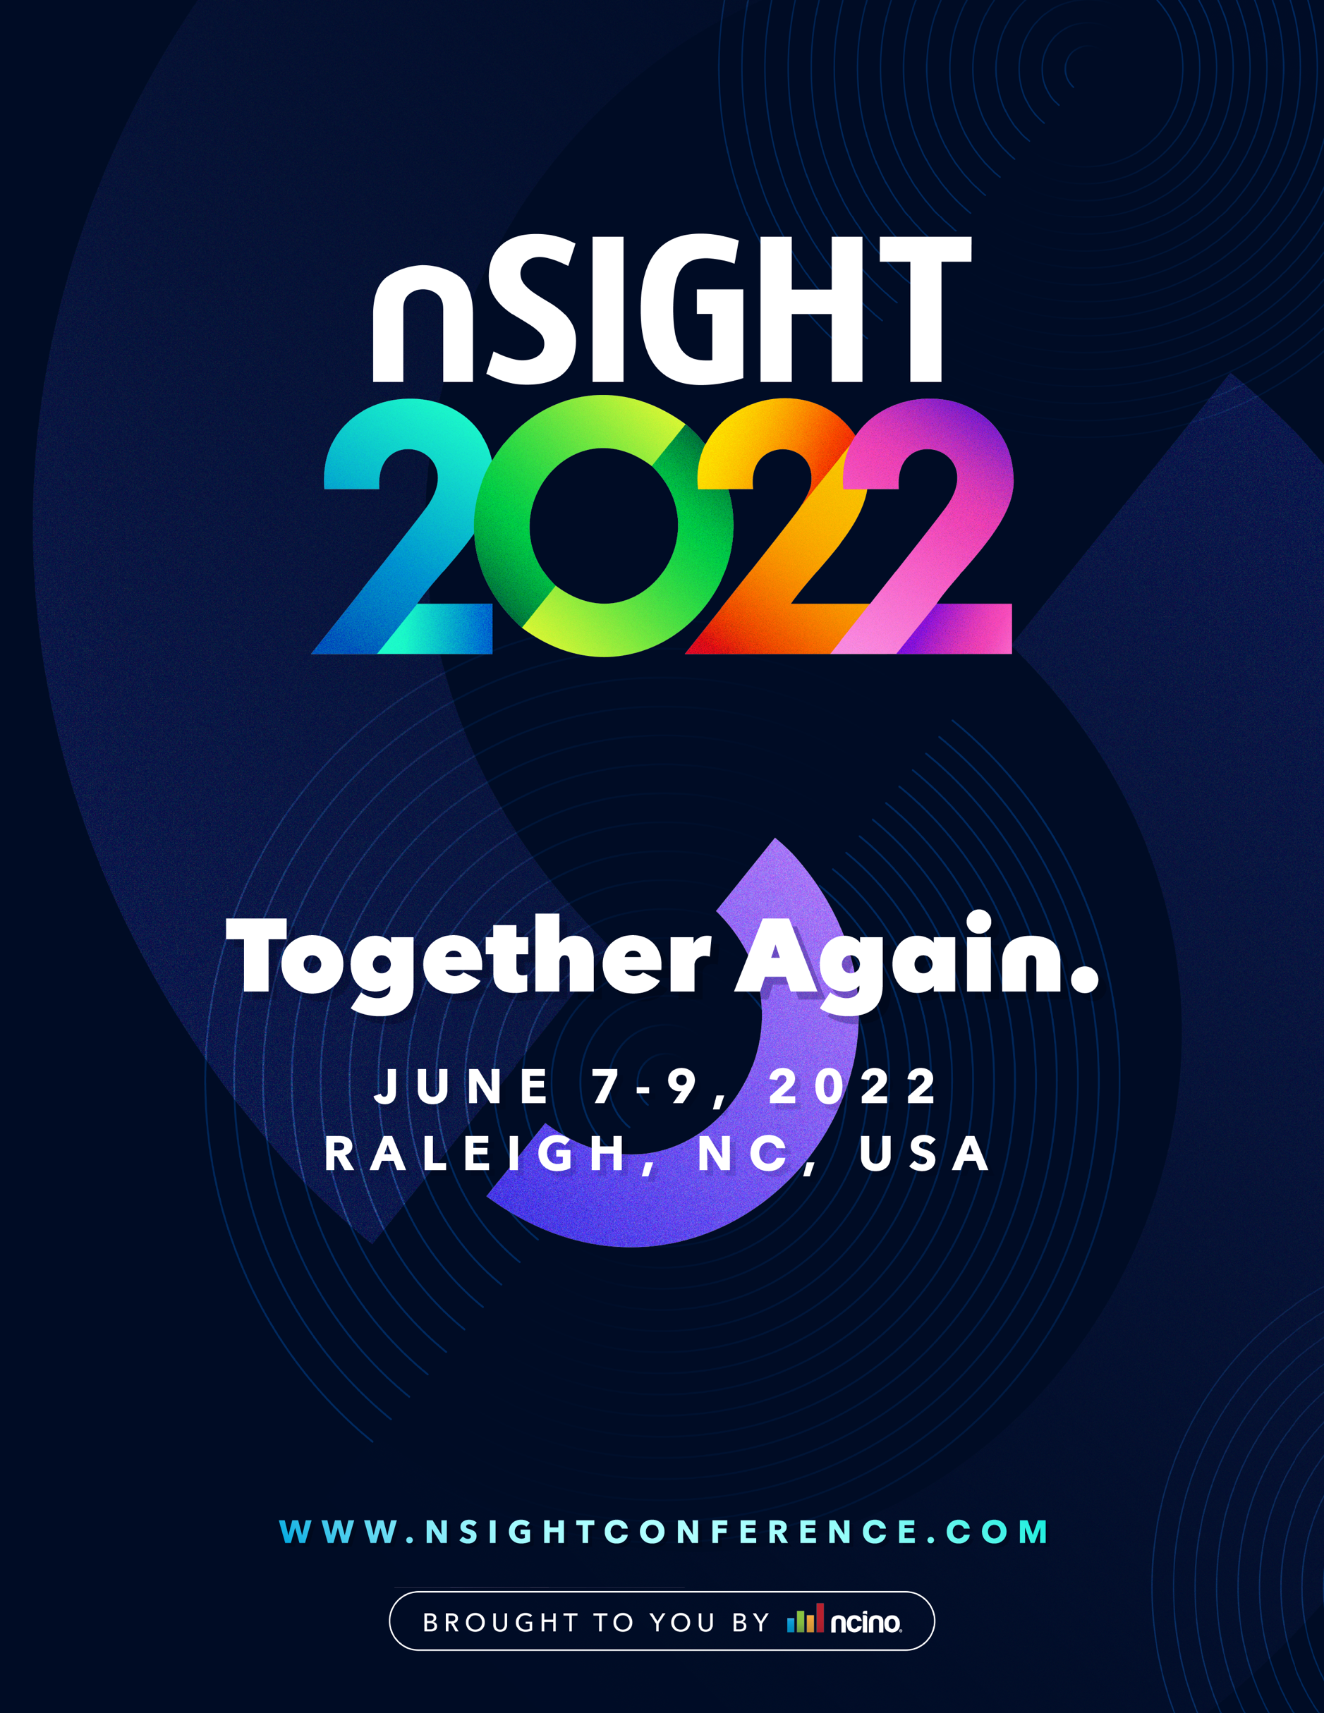

Hello,

I am requesting approval to attend nSight 2022, nCino’s annual user conference, which will take place this year in-person June 7-9, 2022, at the Raleigh Convention Center in Raleigh, NC.

Each year, this premier financial services event gathers over 1,000 representatives from global enterprise banks, regional and community banks and credit unions to hear from visionary leaders, discuss industry trends, share best practices and explore the latest features and functionality of the nCino Bank Operating System.

At nSight 2022, I will be able to expand my knowledge and bring back actionable insights applicable to our financial institution. In particular, I think the following conference highlights will be most valuable:

- Access to nCino Experts – This year’s Community Lounge will provide ample opportunities to have one-on-one conversations with nCino experts, as well as hands-on demos of product solutions and features.

- Ideas from Insightful Speakers – nSight 2022 will feature a variety of concurrent keynotes, breakout sessions, roundtable discussions, networking opportunities and bespoke experiences, giving me the freedom to build an agenda tailored to my unique interests and our financial institutions needs.
  - [attendee to insert specific keynote or breakout sessions of interest once sessions have been published: (https://www.nsightconference.com/agenda)]

- New Professional Connections – With over 16 hours of networking opportunities, I can create long-lasting relationships with other nCino users and financial institutions. It will be helpful to have this network for continued collaboration after the conference is complete.

[attendee to delete the following section if not interested in University @ nSight pre-conference training]
- Hands-On Training - University @ nSight pre-conference training courses provide in-depth sessions and hands-on training so I can learn new skills that will help me configure and maximize our use of the nCino Bank Operating System.

I look forward to also submitting a post-conference report that will include a summary of major takeaways, best practices we can utilize at our institution and a set of recommendations to maximize our current investments in nCino. I can also share relevant information with key personnel throughout the company.

Here is an approximate breakdown of conference costs:

Registration Early Bird (valid until 3/31) - $499
Standard Price (valid until 5/31) - $599
University @ nSight $1000 [*if applicable]
Airfare $xxx [estimated from (your location) to RDU]
Transportation $xxx
Hotel $xxx [discounted hotel accommodations here] + 13% tax

Total $xxxx

My nSight registration fee includes access to the multi-day conference, a plethora of educational sessions and keynotes, roundtable discussions and networking opportunities. In addition, all meals on Wednesday and Thursday are included.

Thank you for considering this request. Please let me know if I have the sign-off to attend – the earlier I get tickets the more cost-friendly they will be!

[Insert Attendee Name]

